Test Report

For

Natural Language Understanding Module

Version 1.3

Prepared by the Tongue Twisters Project Team:

Andrew Rohn, Eskedar Endashw, Firehiwot Chari, Joseph Kalfus, Leelakrishnan Subramaniam, Malik Webster & Obinna Okonkwo.

November 5th, 2021

Date | Version | Description | Author
October 24, 2021 | 1.0 | Initial Release Template | Firehiwot Chari
November 3, 2021 | 1.1 | Added unit/integration tests | NLU and App team
November 5, 2021 | 1.2 | Added test summaries | Andrew Rohn
November 5, 2021 | 1.3 | Fixed formatting | Joseph Kalfus

Table of Contents
1. Introduction 5
1.1 Purpose 5
1.2 Application Overview 5
1.3 Intended Audience 5
1.4 Technical Project Stakeholders 5
2. Type of Testing 6
2.1 General Unit Testing 6
2.2 Integration Testing 7
3. Test Summary 7
3.1 Unit Testing 7
3.2 User Acceptance Testing 9
3.2.1 Responds to the User Saying: “Hello” 9
3.2.2 Responds to the User Saying: “How are you?” 11
3.2.3 Responds to the User Saying: “What is your name?” 12
3.2.4 Responds to the User Giving a Compliment 13
3.2.5 Responds to the User Giving an Insult 14
3.2.6 Responds to the User Saying: “Thank You” 15
3.2.7 Responds to the User Saying: “Goodbye” 16
3.2.8 Navigates User to Calendar Screen 17
3.2.9 Navigates User to Checklist Screen 18
3.2.10 Navigates User to Help Screen 19
3.2.11 Navigates User to Menu Screen 20
3.2.12 Navigates User to Notes Screen 21
3.2.13 Navigates User to Notifications Screen 22
3.2.14 Navigates User to Settings Screen 23
3.2.15 Navigates User to Trigger Screen 24
3.2.16 Creates a Note 25
3.2.17 Creates an Event 26
3.2.18 Creates a Recurring Event 27
3.2.19 Answers the User’s Question 28
4. Item Not Tested 29
5. Defects Identified 29
6. Exit Criteria 29
7. Appendices 29
7.1 Credits & Contributions 29

1. Introduction

1.1 Purpose
The purpose of this test report is to evaluate if the developed software satisfied all targeted requirements. The test report shows the objective of testing and results of the Natural Language Understanding (NLU) module developed for Memory Magic Application. The test report will help all stakeholders to see the result and guide the development team on a decision to release the software.

1.2 Application Overview
The application is developed with the objective of developing an NLU module that is seamlessly integrated into the Memory Magic Application. The application will be used by people with a short-term memory loss (STM). The mobile application will save notes and calendars and will provide answers for text and voice enquires by searching from saved calendars and notes.

1.3 Intended Audience
The objective of this test document is to explain the testing activities of the NLU module which integrated with the Memory Magic application. This document is intended for developers, project managers, business analysts, the testing team and end users to better understand the system performance.

1.4 Technical Project Stakeholders
Table 1
Project Stakeholders
Name | Role
Dr. Mir Assadullah | Stakeholder (Project Owner)
Roy Gordon | Stakeholder (Project Advisor)
Endalkachew Girma | Overall Project Manager
Obinna Okonkwo | (PM) Project Manager
Andrew Rohn | Software Developer
Eskedar Endashw | Database Developer
Firehiwot Chari | Tester
Joseph Kalfus | System Analyst
Leelakrishnan Subramaniam | Software Developer
Malik Webster | Software Developer

2. Type of Testing
The unit and integration tests will be using a white box approach to testing. User integration testing will be done within the smartphone application to document queries and responses from a typical user’s perspective.

2.1 General Unit Testing
These unit tests were created before the start of the development cycle (previous milestone). The tests were executed either within the Amazon Lex Console, an actual iPhone or Android phone, or within the Android emulator.
Table 2
General Unit Tests and Results
General Tests: Application Help | Amazon Lex Console
1. “How do I make a note?”  Success case: Display “Let me help you with that.” in the chat window. | Passed
2. “How do I change choose a different language?”  Success case: Direct the user to the help screen for the app feature. | Passed
App Navigation | iPhone | Android
3. “Take me to the main menu.”  Success case: Display “Taking you to the Menu screen.” in the chat window. | Passed | Passed
4. “I want to see my notes.”  Success case: Direct the user to the screen identified from the text. | Passed | Passed
Answering
5. “How’s it going?”  Success case: Take to the appropriate screen and display it in the chat window. | Passed | Passed
Creating a note
6. “I need to pick up eggs tomorrow.”  Success case: Create a new note with what is given.  Display “I created a note for you.” in the chat window.  (Optional) Direct the user to the notes screen. | Passed | Passed
User Location
7. “Where am I?”  Success case: Determine the user’s location via an API or library.  Either display their location (e.g., open Google Maps) or state their location (e.g., “You are at Park Place in Townsville, CA.”). | Passed | Passed

2.2 Integration Testing
Integration Tests | iPhone Emulator | Android Emulator
1. Application handles successful response from NLU API.  Success case: Obtain desired response. | See Below | See Below
2. Application handles all non-success responses from NLU API.  Success case: Error is handled gracefully. | See Below | See Below

3. Test Summary

3.1 Unit Testing
The following unit tests were specified in the original requirements document and are listed here with its related status. Unit tests are documented in Table 3.
Table 3
More Specific NLU Unit Tests
 | Unit Test Construction Status
- Greeting Test  “hello” is passed as input, I'm fine. Thanks. Is obtained as response from NLUResponse. | Verified
- What is your name Test  “What is your name” is passed as input, “You can call me Sam.” Is obtained as response from NLUResponse. | Verified
- I like you Test  “I like you” is passed as input, “Thanks.” Is obtained as response from NLUResponse. | Verified
- I hate you Test  “I hate you” is passed as input, “If you don't have anything nice to say, don't say anything at all.” Is obtained as response from NLUResponse. | Verified
- Thank you Test  “Thank you” is passed as input, “I'm happy to help.” Is obtained as response from NLUResponse. | Verified
- Goodbye Test  “goodbye” is passed as input, “Bye.” Is obtained as response from NLUResponse. | Verified
- I want to see my events Test  “I want to see my events” is passed as input, “calendar” Is obtained as response from NLUResponse. | Verified
- Take me to the home page Test  “Take me to the home page” is passed as input, “menu” Is obtained as response from NLUResponse. | Verified
- I want to make a note Test  “I want to make a note” is passed as input, “notes.” Is obtained as response from NLUResponse. | Verified
- I want to check my notifications Test  “I want to check my notifications” is passed as input, “notifications” Is obtained as response from NLUResponse. | Verified
- I need to adjust my settings Test  “I need to adjust my settings” is passed as input, “settings” Is obtained as response from NLUResponse. | Verified
- I want to change my trigger phrase Test  “I want to change my trigger phrase” is passed as input, “ActionType.CREATE_NOTE.” Is obtained as response from NLUResponse’s ActionType. | Verified
- I have a meeting tomorrow at 6pm Test  “I have a meeting tomorrow at 6pm” is passed as input, “meeting.” Is obtained as response from NLUResponse’s eventType. | Verified

3.2 User Acceptance Testing

3.2.1 Responds to the User Saying: “Hello”
Table 4
Responds to the User Saying: “Hello”
Test Name | Responds to the User Saying: “Hello”
Test Type | User Acceptance Testing
Test Date | November 1st, 2021
Tester | Andrew Rohn
Software | Android Studio Arctic Fox 2020.3.1 Patch 3  Flutter 2.5.1  Dart 2.14.2
Emulator | Android Pixel 4 XL API 30
Steps | - User taps the mic icon in the app and says something like: “hello”  - The user’s voice is transcribed from voice to text and passed to the NLU Module  - The NLU Module identifies the intent of the user’s speech as “Hello”  - The NLU Module returns text that states something like: “Nice to meet you.”  - The app displays the text and does text-to-voice
Expected Result | App displays and says something like: “Nice to meet you.”
Issues | None
Status | Passed
Screenshots | 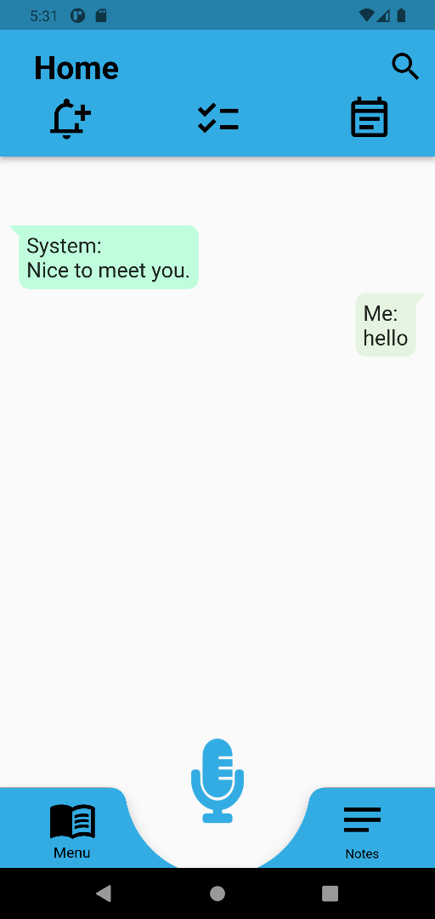

3.2.2 Responds to the User Saying: “How are you?”
Table 5
Responds to the User Saying: “How are you?”
Test Name | Responds to the User Saying: “How are you?”
Test Type | User Acceptance Testing
Test Date | November 1st, 2021
Tester | Andrew Rohn
Software | Android Studio Arctic Fox 2020.3.1 Patch 3  Flutter 2.5.1  Dart 2.14.2
Emulator | Android Pixel 4 XL API 30
Steps | - User taps the mic icon in the app and says something like: “how are you”  - The user’s voice is transcribed from voice to text and passed to the NLU Module  - The NLU Module identifies the intent of the user’s speech as “HowAreYou”  - The NLU Module returns text that states something like: “I’m doing great. Thanks for asking.”  - The app displays the text and does text-to-voice
Expected Result | App displays and says something like: “I’m doing great. Thanks for asking.”
Issues | None
Status | Passed
Screenshots | 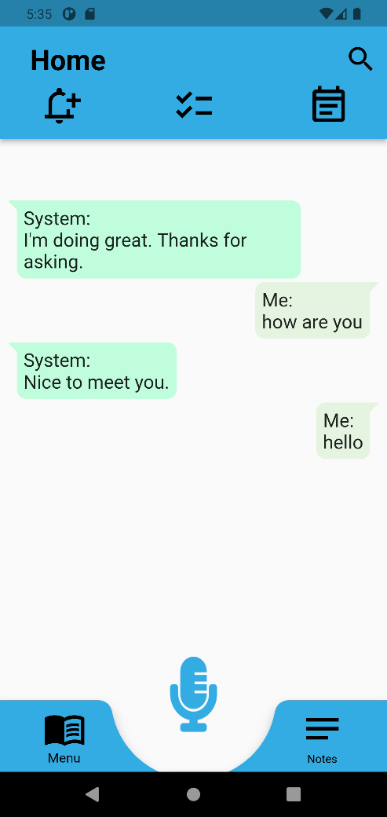

3.2.3 Responds to the User Saying: “What is your name?”
Table 6
Responds to the User Saying: “What is your name?”
Test Name | Responds to the User Saying: “What is your name?”
Test Type | User Acceptance Testing
Test Date | November 1st, 2021
Tester | Andrew Rohn
Software | Android Studio Arctic Fox 2020.3.1 Patch 3  Flutter 2.5.1  Dart 2.14.2
Emulator | Android Pixel 4 XL API 30
Steps | - User taps the mic icon in the app and says something like: “what is your name”  - The user’s voice is transcribed from voice to text and passed to the NLU Module  - The NLU Module identifies the intent of the user’s speech as “WhatIsYourName”  - The NLU Module returns text that states something like: “My name is Sam.”  - The app displays the text and does text-to-voice
Expected Result | App displays and says something like: “My name is Sam.”
Issues | None
Status | Passed
Screenshots | 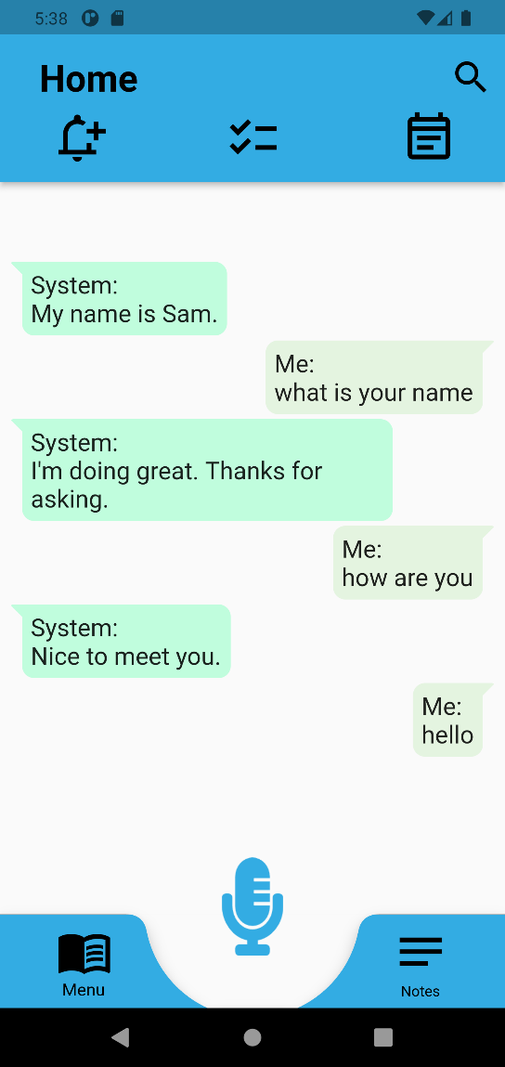

3.2.4 Responds to the User Giving a Compliment
Table 7
Responds to the User Giving a Compliment
Test Name | Responds to the User Giving a Compliment
Test Type | User Acceptance Testing
Test Date | November 1st, 2021
Tester | Andrew Rohn
Software | Android Studio Arctic Fox 2020.3.1 Patch 3  Flutter 2.5.1  Dart 2.14.2
Emulator | Android Pixel 4 XL API 30
Steps | - User taps the mic icon in the app and says something like: “I like you”  - The user’s voice is transcribed from voice to text and passed to the NLU Module  - The NLU Module identifies the intent of the user’s speech as “Compliment”  - The NLU Module returns text that states something like: “Thank you.”  - The app displays the text and does text-to-voice
Expected Result | App displays and says something like: “Thank you.”
Issues | None
Status | Passed
Screenshots | 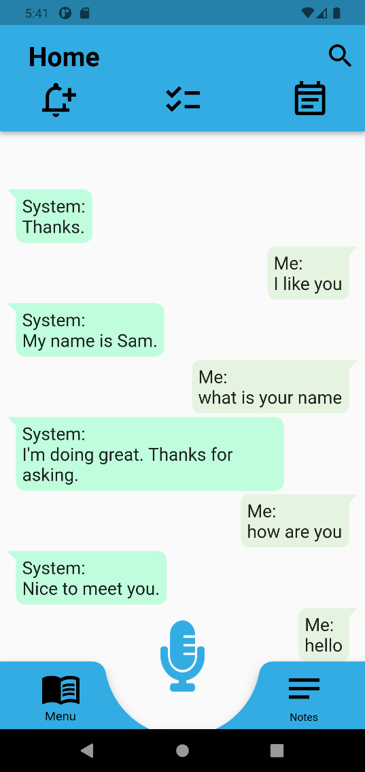

3.2.5 Responds to the User Giving an Insult
Table 8
Responds to the User Giving an Insult
Test Name | Responds to the User Giving an Insult
Test Type | User Acceptance Testing
Test Date | November 1st, 2021
Tester | Andrew Rohn
Software | Android Studio Arctic Fox 2020.3.1 Patch 3  Flutter 2.5.1  Dart 2.14.2
Emulator | Android Pixel 4 XL API 30
Steps | - User taps the mic icon in the app and says something like: “I hate you”  - The user’s voice is transcribed from voice to text and passed to the NLU Module  - The NLU Module identifies the intent of the user’s speech as “Insult”  - The NLU Module returns text that states something like: “I’m sorry you feel that way.”  - The app displays the text and does text-to-voice
Expected Result | App displays and says something like: “I’m sorry you feel that way.”
Issues | None
Status | Passed
Screenshots | 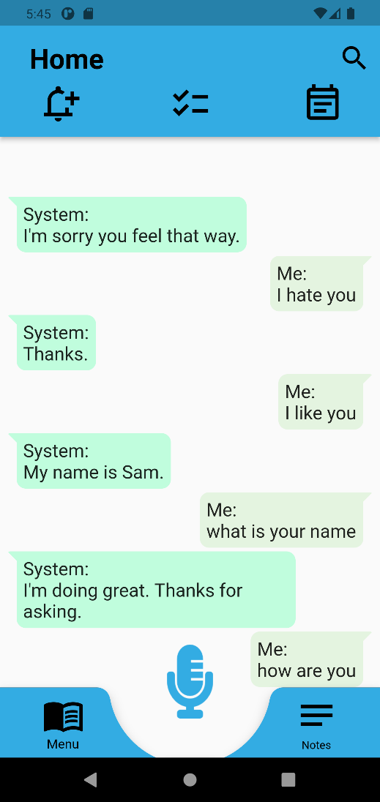

3.2.6 Responds to the User Saying: “Thank You”
Table 9
Responds to the User Saying: “Thank You”
Test Name | Responds to the User Saying: “Thank You”
Test Type | User Acceptance Testing
Test Date | November 1st, 2021
Tester | Andrew Rohn
Software | Android Studio Arctic Fox 2020.3.1 Patch 3  Flutter 2.5.1  Dart 2.14.2
Emulator | Android Pixel 4 XL API 30
Steps | - User taps the mic icon in the app and says something like: “thank you”  - The user’s voice is transcribed from voice to text and passed to the NLU Module  - The NLU Module identifies the intent of the user’s speech as “ThankYou”  - The NLU Module returns text that states something like: “You’re welcome.”  - The app displays the text and does text-to-voice
Expected Result | App displays and says something like: “You’re welcome.”
Issues | None
Status | Passed
Screenshots | 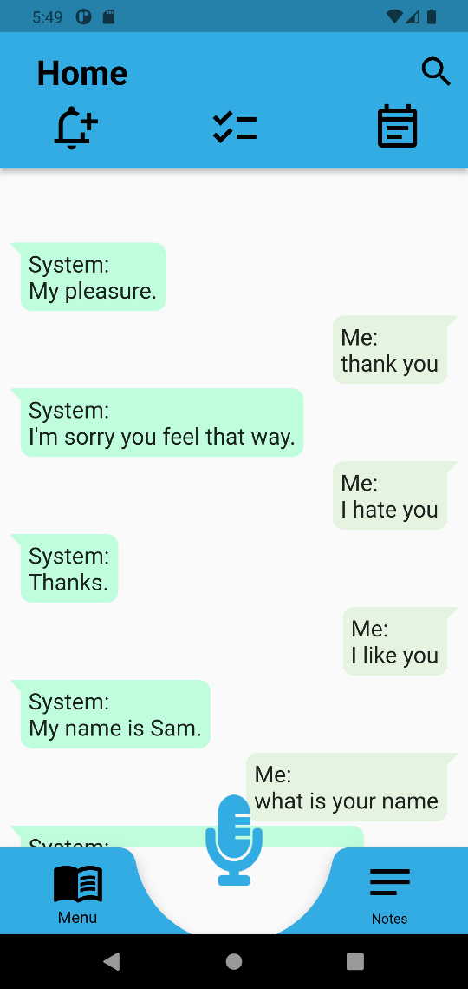

3.2.7 Responds to the User Saying: “Goodbye”
Table 10
Responds to the User Saying: “Goodbye”
Test Name | Responds to the User Saying: “Goodbye”
Test Type | User Acceptance Testing
Test Date | November 1st, 2021
Tester | Andrew Rohn
Software | Android Studio Arctic Fox 2020.3.1 Patch 3  Flutter 2.5.1  Dart 2.14.2
Emulator | Android Pixel 4 XL API 30
Steps | - User taps the mic icon in the app and says something like: “goodbye”  - The user’s voice is transcribed from voice to text and passed to the NLU Module  - The NLU Module identifies the intent of the user’s speech as “Goodbye”  - The NLU Module returns text that states something like: “Goodbye.”  - The app displays the text and does text-to-voice
Expected Result | App displays and says something like: “Goodbye.”
Issues | None
Status | Passed
Screenshots | 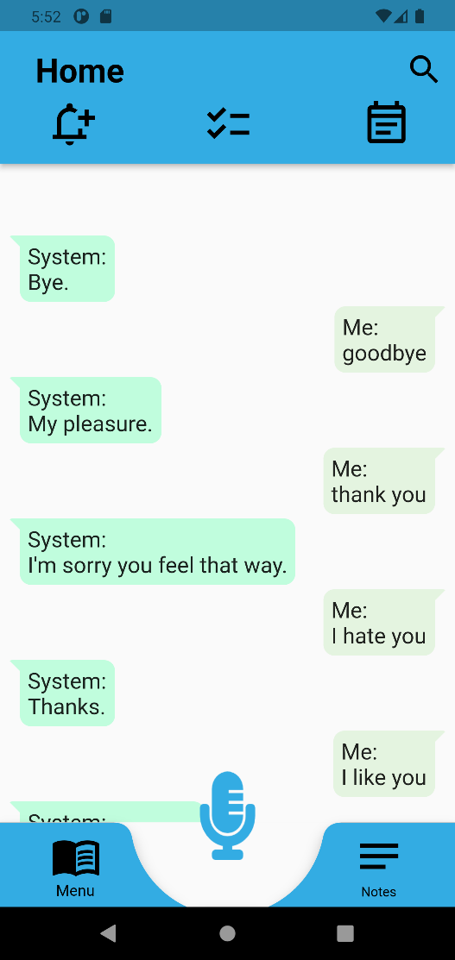

3.2.8 Navigates User to Calendar Screen
Table 11
Navigates User to Calendar Screen
Test Name | Navigates User to Calendar Screen
Test Type | User Acceptance Testing
Test Date | November 1st, 2021
Tester | Andrew Rohn
Software | Android Studio Arctic Fox 2020.3.1 Patch 3  Flutter 2.5.1  Dart 2.14.2
Emulator | Android Pixel 4 XL API 30
Steps | - User taps the mic icon in the app and says something like: “I want to see my events”  - The user’s voice is transcribed from voice to text and passed to the NLU Module  - The NLU Module identifies the intent of the user’s speech as “AppNavCalendar”  - The NLU Module instructs the app to direct the user to the calendar screen  - The app directs the user to the calendar screen
Expected Result | App directs the user to the calendar screen
Issues | None
Status | Passed
Screenshots | 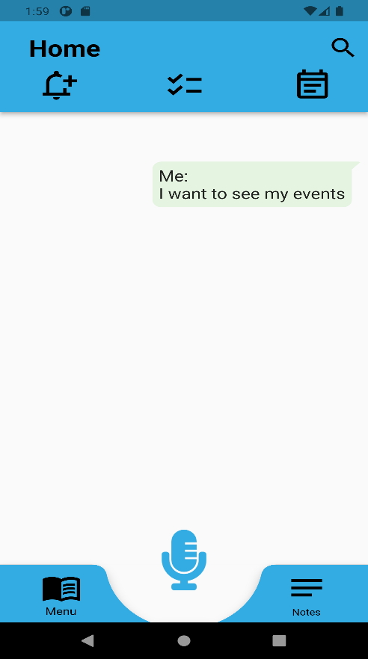 | 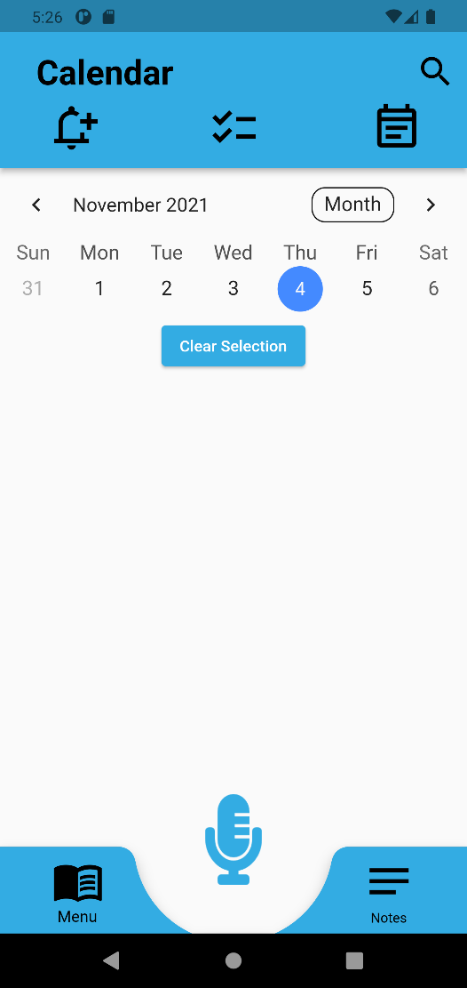

3.2.9 Navigates User to Checklist Screen
Table 12
Navigates User to Checklist Screen
Test Name | Navigates User to Checklist Screen
Test Type | User Acceptance Testing
Test Date | November 1st, 2021
Tester | Andrew Rohn
Software | Android Studio Arctic Fox 2020.3.1 Patch 3  Flutter 2.5.1  Dart 2.14.2
Emulator | Android Pixel 4 XL API 30
Steps | - User taps the mic icon in the app and says something like: “show me my checklist”  - The user’s voice is transcribed from voice to text and passed to the NLU Module  - The NLU Module identifies the intent of the user’s speech as “AppNavChecklist”  - The NLU Module instructs the app to direct the user to the checklist screen  - The app directs the user to the checklist screen
Expected Result | App directs the user to the checklist screen
Issues | None
Status | Passed
Screenshots | 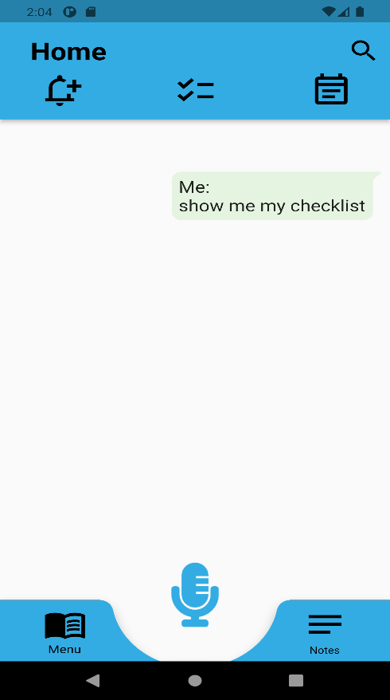 | 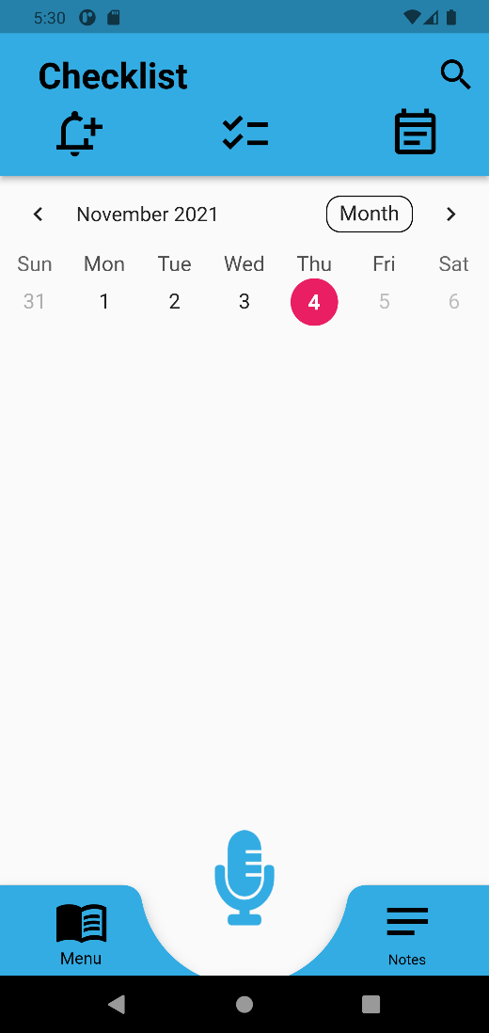

3.2.10 Navigates User to Help Screen
Table 13
Navigates User to Help Screen
Test Name | Navigates User to Help Screen
Test Type | User Acceptance Testing
Test Date | November 1st, 2021
Tester | Andrew Rohn
Software | Android Studio Arctic Fox 2020.3.1 Patch 3  Flutter 2.5.1  Dart 2.14.2
Emulator | Android Pixel 4 XL API 30
Steps | - User taps the mic icon in the app and says something like: “I need help with the app”  - The user’s voice is transcribed from voice to text and passed to the NLU Module  - The NLU Module identifies the intent of the user’s speech as “AppNavHelp”  - The NLU Module instructs the app to direct the user to the help screen  - The app directs the user to the help screen
Expected Result | App directs the user to the help screen
Issues | None
Status | Passed
Screenshots | 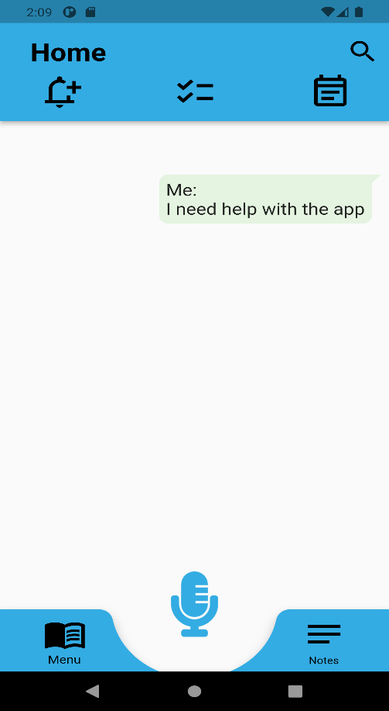 | 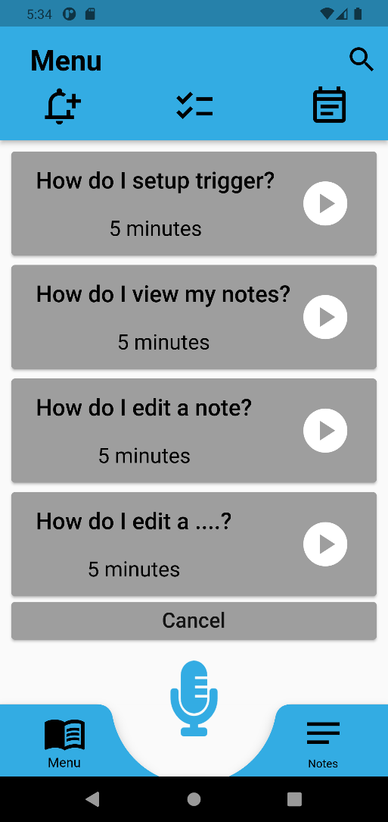

3.2.11 Navigates User to Menu Screen
Table 14
Navigates User to Menu Screen
Test Name | Navigates User to Menu Screen
Test Type | User Acceptance Testing
Test Date | November 1st, 2021
Tester | Andrew Rohn
Software | Android Studio Arctic Fox 2020.3.1 Patch 3  Flutter 2.5.1  Dart 2.14.2
Emulator | Android Pixel 4 XL API 30
Steps | - User taps the mic icon in the app and says something like: “take me to the main menu”  - The user’s voice is transcribed from voice to text and passed to the NLU Module  - The NLU Module identifies the intent of the user’s speech as “AppNavMenu”  - The NLU Module instructs the app to direct the user to the menu screen  - The app directs the user to the menu screen
Expected Result | App directs the user to the menu screen
Issues | None
Status | Passed
Screenshots | 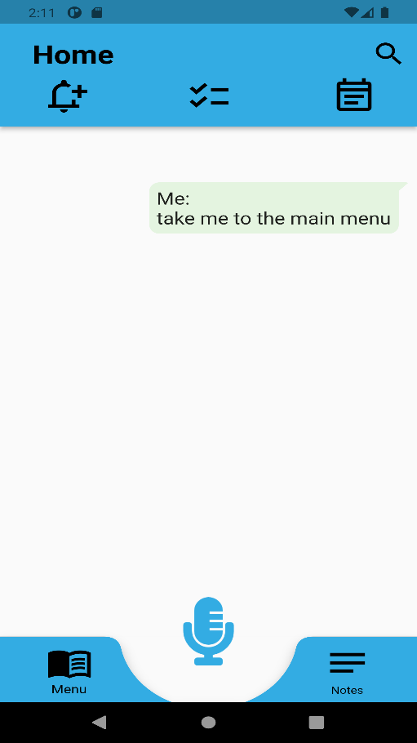 | 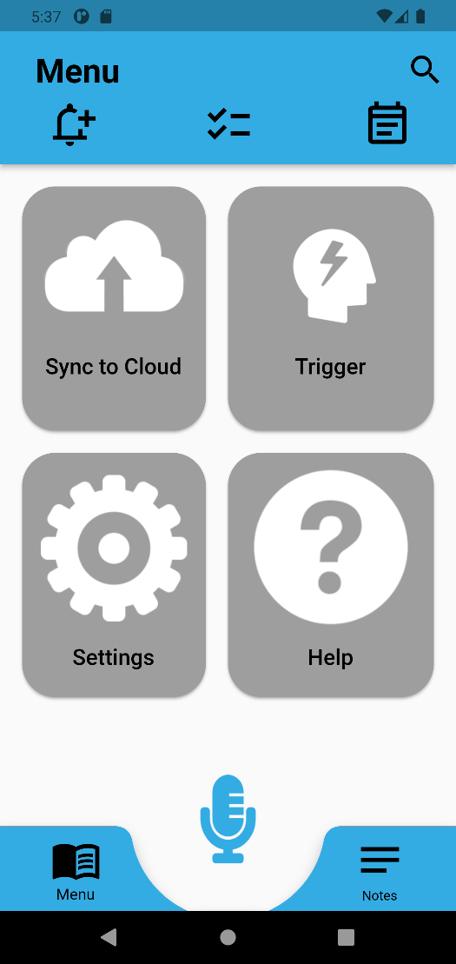

3.2.12 Navigates User to Notes Screen
Table 15
Navigates User to Notes Screen
Test Name | Navigates User to Notes Screen When Prompted
Test Type | User Acceptance Testing
Test Date | November 1st, 2021
Tester | Andrew Rohn
Software | Android Studio Arctic Fox 2020.3.1 Patch 3  Flutter 2.5.1  Dart 2.14.2
Emulator | Android Pixel 4 XL API 30
Steps | - User taps the mic icon in the app and says something like: “I want to make a note”  - The user’s voice is transcribed from voice to text and passed to the NLU Module  - The NLU Module identifies the intent of the user’s speech as “AppNavNotes”  - The NLU Module instructs the app to direct the user to the notes screen  - The app directs the user to the notes screen
Expected Result | App directs the user to the notes screen
Issues | None
Status | Passed
Screenshots | 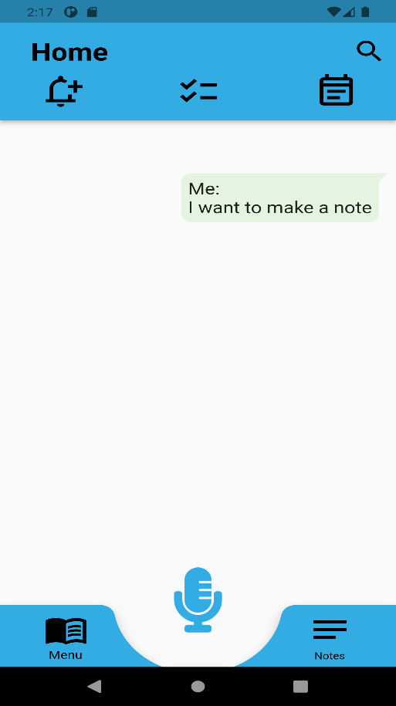 | 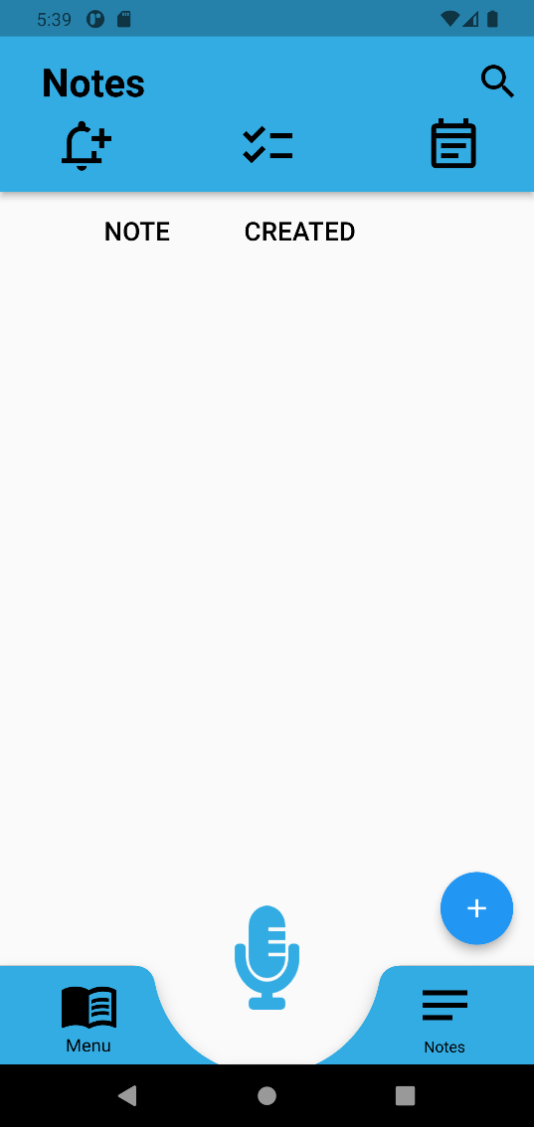

3.2.13 Navigates User to Notifications Screen
Table 16
Navigates User to Notifications Screen
Test Name | Navigates User to Notifications Screen
Test Type | User Acceptance Testing
Test Date | November 1st, 2021
Tester | Andrew Rohn
Software | Android Studio Arctic Fox 2020.3.1 Patch 3  Flutter 2.5.1  Dart 2.14.2
Emulator | Android Pixel 4 XL API 30
Steps | - User taps the mic icon in the app and says something like: “I want to check my notifications”  - The user’s voice is transcribed from voice to text and passed to the NLU Module  - The NLU Module identifies the intent of the user’s speech as “AppNavNotifications”  - The NLU Module instructs the app to direct the user to the notifications screen  - The app directs the user to the notifications screen
Expected Result | App directs the user to the notifications screen
Issues | None
Status | Passed
Screenshots | 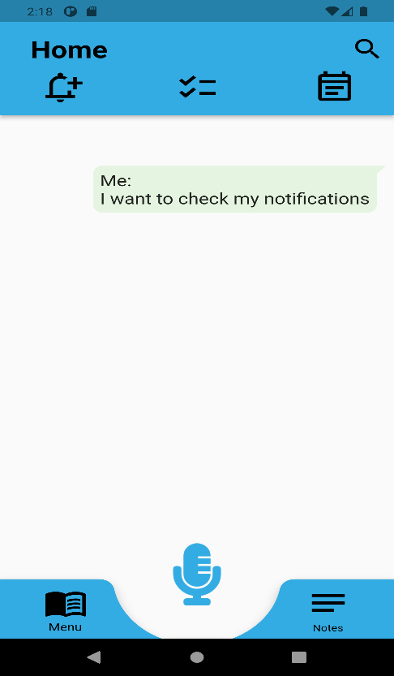 | 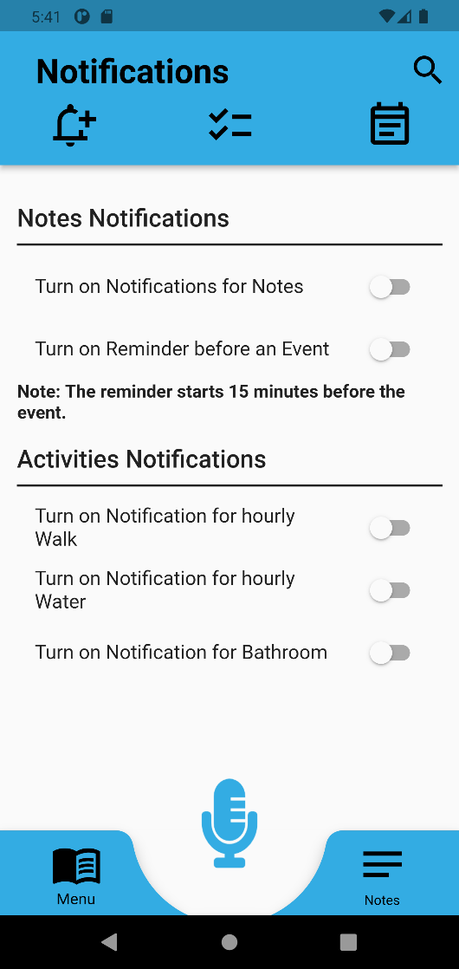

3.2.14 Navigates User to Settings Screen
Table 17
Navigates User to Settings Screen
Test Name | Navigates User to Settings Screen
Test Type | User Acceptance Testing
Test Date | November 1st, 2021
Tester | Andrew Rohn
Software | Android Studio Arctic Fox 2020.3.1 Patch 3  Flutter 2.5.1  Dart 2.14.2
Emulator | Android Pixel 4 XL API 30
Steps | - User taps the mic icon in the app and says something like: “I need to adjust my settings”  - The user’s voice is transcribed from voice to text and passed to the NLU Module  - The NLU Module identifies the intent of the user’s speech as “AppNavSettings”  - The NLU Module instructs the app to direct the user to the settings screen  The app directs the user to the settings screen
Expected Result | App directs the user to the settings screen
Issues | None
Status | Passed
Screenshots | 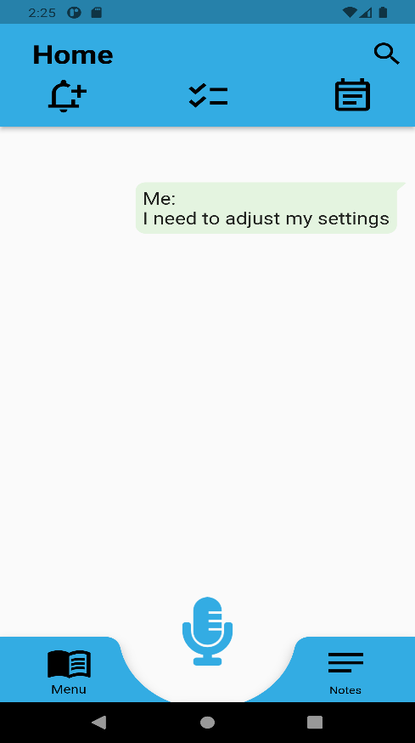 | 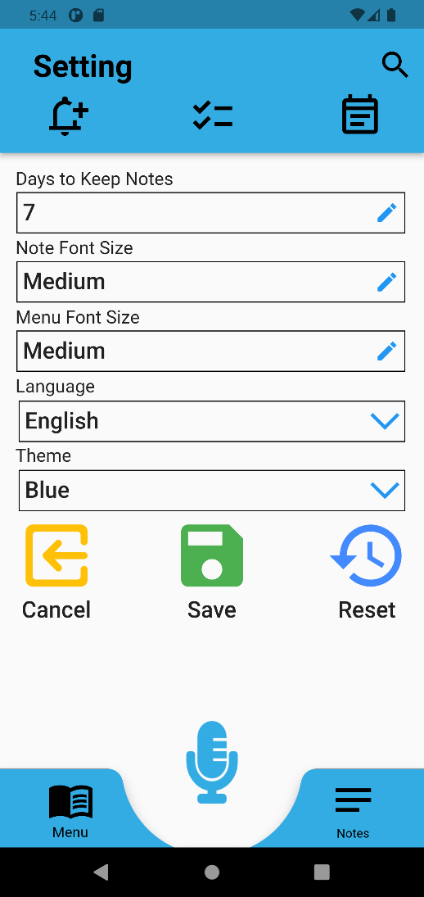

3.2.15 Navigates User to Trigger Screen
Table 18
Navigates User to Trigger Screen
Test Name | Navigates User to Trigger Screen
Test Type | User Acceptance Testing
Test Date | November 1st, 2021
Tester | Andrew Rohn
Software | Android Studio Arctic Fox 2020.3.1 Patch 3  Flutter 2.5.1  Dart 2.14.2
Emulator | Android Pixel 4 XL API 30
Steps | - User taps the mic icon in the app and says something like: “I want to change my trigger phrase”  - The user’s voice is transcribed from voice to text and passed to the NLU Module  - The NLU Module identifies the intent of the user’s speech as “AppNavTrigger”  - The NLU Module instructs the app to direct the user to the trigger screen  - The app directs the user to the trigger screen
Expected Result | App directs the user to the trigger screen
Issues | None
Status | Passed
Screenshots | 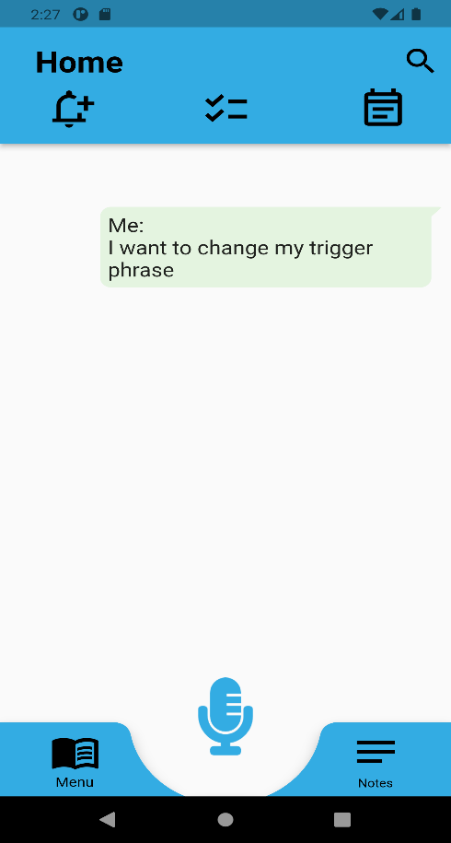 | 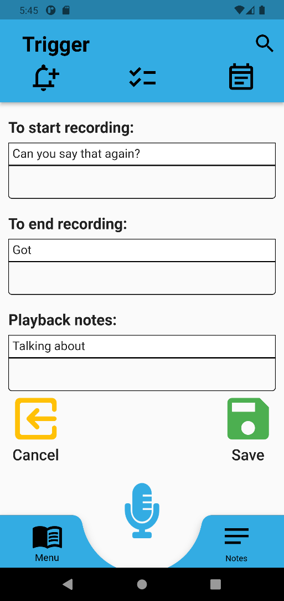

3.2.16 Creates a Note
Table 19
Creates a Note
Test Name | Creates a Note
Test Type | User Acceptance Testing
Test Date | November 1st, 2021
Tester | Andrew Rohn
Software | Android Studio Arctic Fox 2020.3.1 Patch 3  Flutter 2.5.1  Dart 2.14.2
Emulator | Android Pixel 4 XL API 30
Steps | - User taps the mic icon in the app and says something like: “I have a son named David”  - The user’s voice is transcribed from voice to text and passed to the NLU Module  - The NLU Module identifies the intent of the user’s speech as “CreateNote”  - The NLU Module instructs the app to ask if the user wants to create a note  - If the user says yes, the app creates a note containing the information
Expected Result | App asks the user if they want to create a note. If the user says yes, the app creates a note containing the information.
Issues | None
Status | Passed
Screenshots | 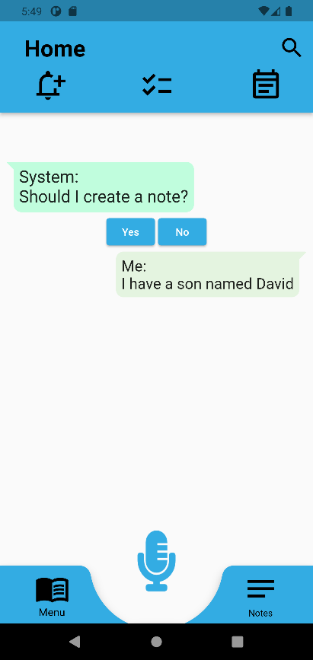 | 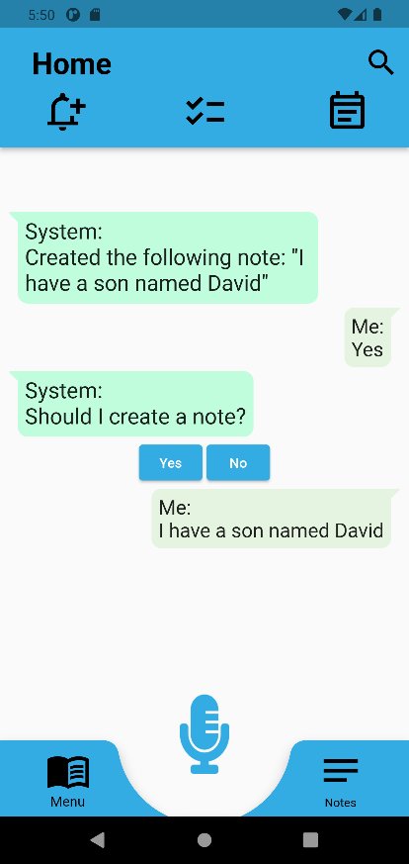 | 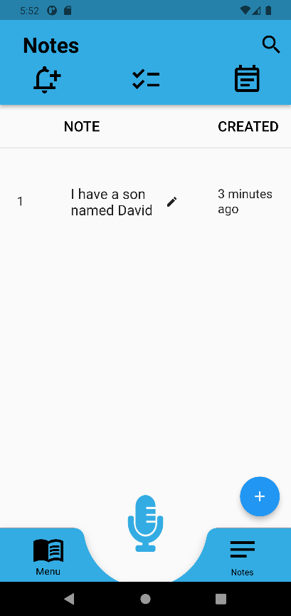

3.2.17 Creates an Event
Table 20
Creates an Event
Test Name | Creates an Event (A Note with a Date & Time)
Test Type | User Acceptance Testing
Test Date | November 1st, 2021
Tester | Andrew Rohn
Software | Android Studio Arctic Fox 2020.3.1 Patch 3  Flutter 2.5.1  Dart 2.14.2
Emulator | Android Pixel 4 XL API 30
Steps | - User taps the mic icon in the app and says something like: “I have a meeting tomorrow at 4 p.m.”  - The user’s voice is transcribed from voice to text and passed to the NLU Module  - The NLU Module identifies the intent of the user’s speech as “CreateEvent”  - The NLU Module instructs the app to ask if the user wants to create a note  - If the user says yes, the app creates a note containing the information including a date and time  - The app adds the event to the user’s calendar
Expected Result | App asks the user if they want to create a note. If the user says yes, the app creates a note containing the information including a date and time. The event is added to the user’s calendar.
Issues | None
Status | Passed
Screenshots | 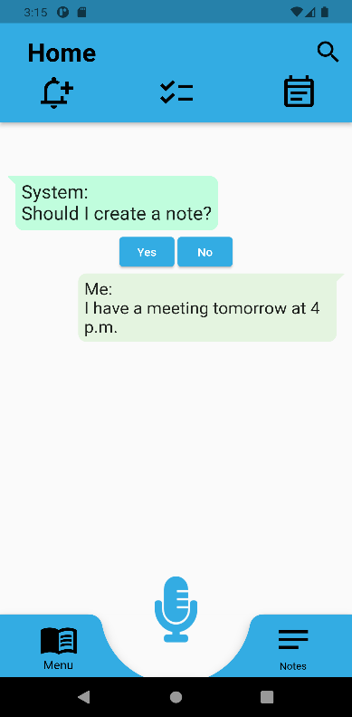 | 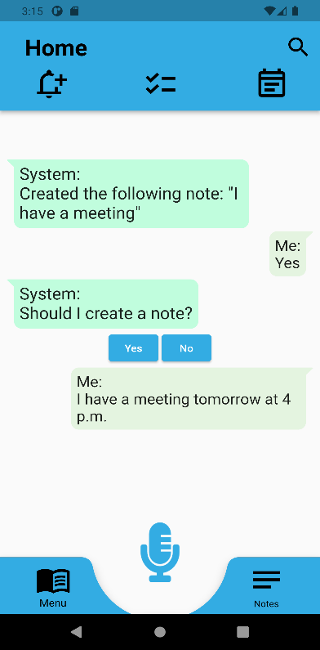 | 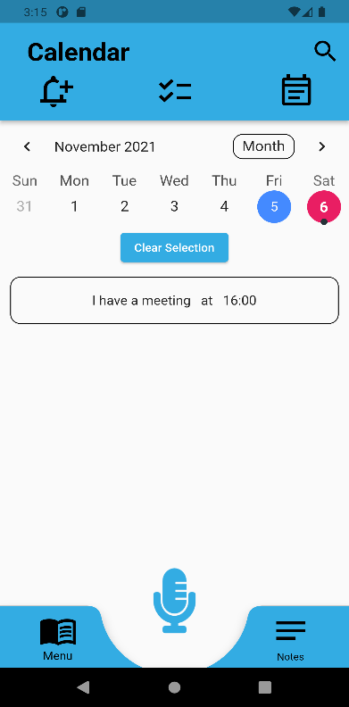

3.2.18 Creates a Recurring Event
Table 21
Creates a Recurring Event
Test Name | Creates a Recurring Event (A Note with a Recurring Period)
Test Type | User Acceptance Testing
Test Date | November 1st, 2021
Tester | Andrew Rohn
Software | Android Studio Arctic Fox 2020.3.1 Patch 3  Flutter 2.5.1  Dart 2.14.2
Emulator | Android Pixel 4 XL API 30
Steps | - User taps the mic icon in the app and says something like: “I need to brush my teeth every day at 8 a.m.”  - The user’s voice is transcribed from voice to text and passed to the NLU Module  - The NLU Module identifies the intent of the user’s speech as “CreateRecurringEvent”  - The NLU Module instructs the app to ask if the user wants to create a note  - If the user says yes, the app creates a note containing the information including a recurring period  - The app adds the recurring event to the user’s checklist
Expected Result | App asks the user if they want to create a note. If the user says yes, the app creates a note containing the information including a recurring period. The recurring event is added to the user’s checklist.
Issues | None
Status | Passed
Screenshots | 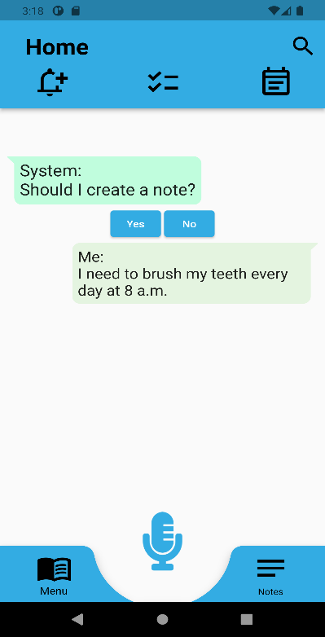 | 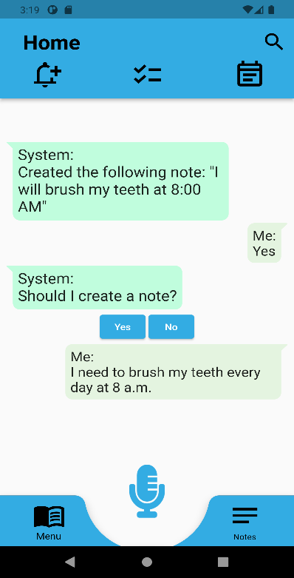 | 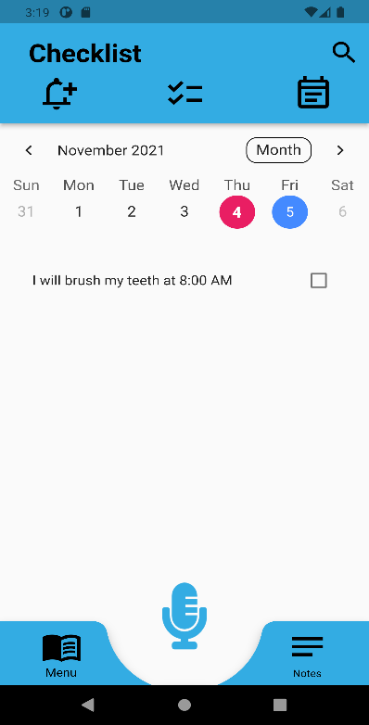

3.2.19 Answers the User’s Question
Table 22
Answers the User’s Question
Test Name | Answers the User’s Question
Test Type | User Acceptance Testing
Test Date | November 1st, 2021
Tester | Andrew Rohn
Software | Android Studio Arctic Fox 2020.3.1 Patch 3  Flutter 2.5.1  Dart 2.14.2
Emulator | Android Pixel 4 XL API 30
Steps | - User taps the mic icon in the app and asks a question  - The user’s voice is transcribed from voice to text and passed to the NLU Module  - The NLU Module identifies the intent of the user’s speech as “SearchNotes”  - The NLU Module searches the user’s notes to find an answer to the question  - The NLU Module returns the most likely answer  - The app displays the answer and does text-to-voice
Expected Result | App displays and says the answer to the user’s question
Issues | None
Status | Passed
Screenshots | 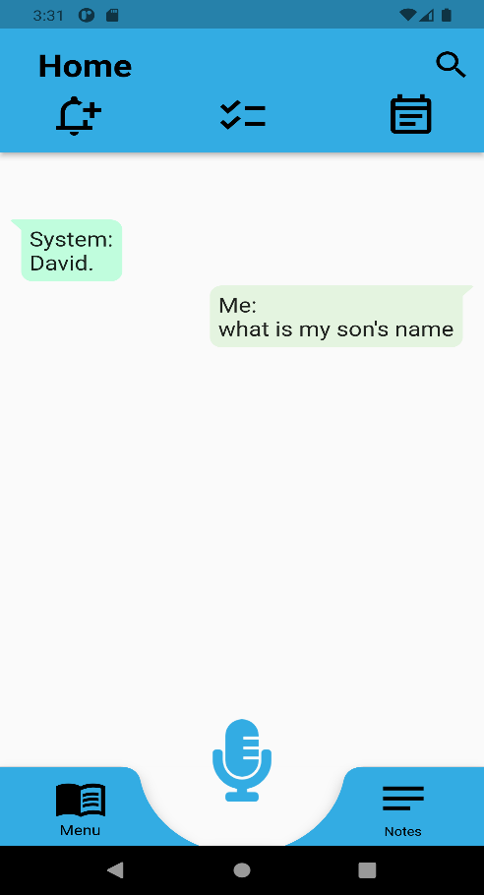

4. Item Not Tested
The App pages was tested by Mesmerize team and was out of scope for this application. AppHelp intents are not tested as part of User Acceptance Testing since the app team did not add functionality in the app to support these intents.

5. Defects Identified
A defect was found in user accept testing in which when asked “I need to buy fruits”, the NLU service returned with “Sorry I could not understand”. This defect is a low severity as it does not affect the overall function of the application, as the events can be added to lex and can be extensible.

6. Exit Criteria
The exit criteria for the completion of testing are the following:
- That all user acceptance testing has been completed and any issues are reported to the development team for correction.
- Unit testing is added for NLU service with all the features tested in User Acceptance testing.
- Any issues found in testing are documented.
- No other test cases are determined as necessary by the team.

7. Appendices

7.1 Credits & Contributions
Below are the members that contributed or will contribute to the development of this application in alphabetical order by last name:
- Aboagye, Prince Antwi
- Ahmed, Christian
- Avery, Daniel
- Baileys, Alec
- Balbi, Teresa
- Ballo, Nicholas
- Bell, Kevin
- Benavides, Raul
- Broggin, Chauntika
- Cabrales, Andreas
- Chari, Firehiwot
- Crumb, Karen
- Cruz Jimenez, Christian
- Cushing, Benjamin
- Drammeh, Mod
- Dunning, Maddison
- Endashw, Eskedar
- Famudehin, Ayodeji
- Girma, Endalkachew
- Gordon, Roy
- Jena, Debashis
- Johnson, Austin
- Johnson, Rebecca
- Kalfus, Joseph
- Kelly, Shawn
- Kimbi, Didimus
- Le, Michael
- Lockhart, Johnny
- Mesfin, Elshaday
- Monfort, Michelle
- Muwan, Presley
- Okonkwo, Obinna
- Olshansky, Mitchell
- Puschinsky, Tyler
- Rohn, Andrew
- Salim, Sami
- Setiawan, Matthew
- Sevilla, Damion
- Soeurt, Jeroen
- Subramanian, Leela
- Webster, Malik
- Wilson, Robert
- Worku, Addisu
- Dr. Mir Mohammed Assadullah

